Invitation
for
Bid And Contract
Nonprofit Tennessee Public Charter Liability Plan and Policy Provider
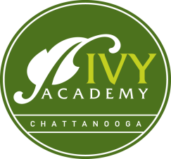
Ivy Academy Chattanooga

In accordance with Federal law, this institution is prohibited from discriminating on the basis of race, color, national origin or religion.
Ivy Academy is seeking bids for its liability insurance policy for the 2017-2018 school year.

We are seeking the following liability coverage plans:
- Directors and Officers Liability
- Workers Compensation
- Commercial Educational Package including property, crime, other

For consideration, bids must include best options and competitive rates. We are particularly looking for a plans that can offer:
- Fast and quality customer service
- Best value for taxpayer’s dollars
- Verifiable reputation of reliability and integrity
- Experience in servicing students in a public education setting

Completed bids should be submitted in writing and mailed or hand delivered to:
Ivy Academy, Liability Insurance Bids
c/o Holly Slater, Director of Operations
8520 Dayton Pike
Soddy-Daisy, TN 37379

Bids should be submitted between May 1, 2017 and May 30, 2017.
The winning bidder will be contacted on June 14, 2017.
For further information, you may email: hslater@ivyacademychattanooga.com .

